Template example
(18 Point, Centred and Bold, Times New Roman)

A. Author¹, B. Author², C. Author³
(List of authors in 10 point, centred and bold: the presenting author underlined)
1- The author affiliation and full address should be located here in 8 point, centred and in italics
2- Address of author² if different
3- Address of author³ if different

Main author email address: in 10 point, centred and in italics

The abstract must be written in English. The abstract will be distributed in a printed abstract book and an electronic file on the conference web site. There will be no formatting done to the abstract prior to publication in the abstract book. Therefore it is very important to ensure that your abstract follows the style guide presented in this template in order to provide a uniform and consistent appearance. Abstract should not exceed one page in length. The dimension of the paper is A4 size paper: 210mm x 297mm. Margins should be 25.4mm on all sides, and the text should be written in 10 point Times New Roman (and Symbol, if necessary).
Mathematical expressions may be included. Variables and function symbols should be italic, mathematical operations should be as text. Formulas should be center aligned and numbered. Numbers should be right aligned as shown in the example below:
 | $$ε^{}\left(ω\right)=\frac{ε_{S}−ε_{∞}}{1+{\left(i\text{ωτ}\right)}^{1−α}}+ε_{∞\text{.}}$$ | ()
A couple of Figures/Tables may be included in the abstract. Authors must ensure that all information in Figures is clearly seen when printed in black and white. Large figures should be centred as shown in the Figure 1, and small ones may be placed side by side. In all cases, the figures must be located completely inside the paper margins. Figure captions, in 8 pt, should be positioned in centre below the figures as shown in Figure 1. Table captions, also in 8 pt, should be positioned centred above the tables.
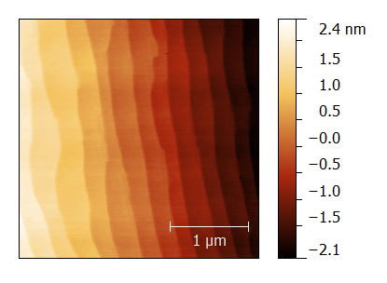
(a) (b)

Figure 1 Captions in 8 point form. (a) The figure, as well as each axis coordinates and titles must be large enough to be easily read. (b) Any micrographs being used should have very good contrast in order to ensure proper visibility. The font of text in the figures should be Arial (and Symbol, if necessary), or the characters are completely part of the picture as (b).
All references should be numbered and appear at the end of the abstract in the same order as used in the text. The font should be the same as the main body of the text but with an 8 pt size. Reference should be aligned to the left. In the main body of the text, the reference designation should be with square brackets [1], and several references can be included together using a comma [2, 3]. If three or more consecutive references occur together, a dash is to be used [1-3].
The abstract must be submitted in MS Word or PDF formats. The quality of figures should be enough for printing (at least 300 dpi). If you have Adobe Acrobat, use “press quality” in PDF setting (conversion setting). It would be emphasized again that the fonts used in the PDF file should be only Times New Roman, Arial, and Symbol in both text and figures.

[1] A. Author and B. Author, Title of paper, Journal Name, vol., pp. startpage-endpage, (year).
[2] A. Author, B. Author, C. Author, Title of paper, Journal Name, vol., pp. start-end, (year).
[3] A. Author, Title of book (Publisher), Chapter, (year).

